I Still Believe in Santa, and You Better, Too!

That’s right. I am a freshman in college, and I believe in Santa Claus. Call me crazy, stupid, childlike and immature! I would rather live a life with Santa Claus and all of his wonders than a life without any of it. I could tell you why, but I think Francis P. Church explains it perfectly, so I’ll deliver my thoughts through his. It’s pretty comical how Francis sums it up so perfectly. Francis was a journalist, penning editorials for the highest of authors, not a childlike bone in his body, and all of a sudden, his response to a curious, confused, hopeful little girl, now becomes an iconic piece of literature the world can use to understand the importance of faith and Christmas. This work of art not only explained Santa Claus’ purpose and realness to this little girl, Virginia, but globally, to people of all ages! His response the most reprinted newspaper article in American history!
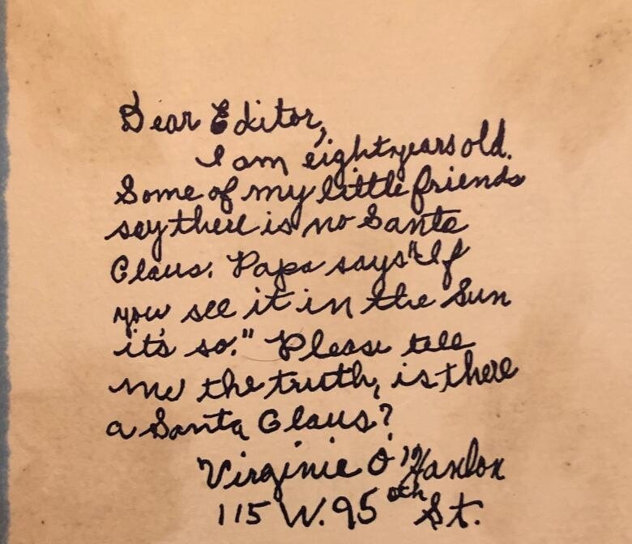
Little 8 year old Laura Virginia O’Hanlon comes home from school one day, overwhelmed with confusion, speaking to her father through her tears about how the children at school told her that Santa Claus isn’t real; so she asks her dad to tell her the truth. His response was, “If it says it in The Sun, it is so” (their local newspaper in New York). So, what else for Virgina to do than to write to The New York Sun with her questions.
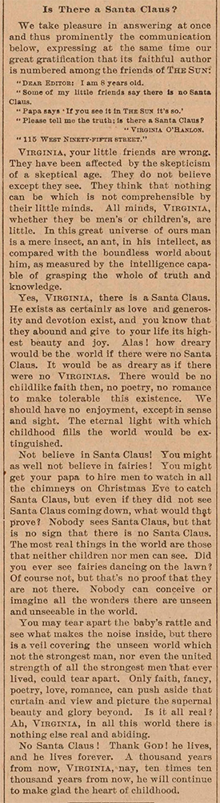
The response she received was full of incredible insight, encouraging language, and highly-impactful words. In just under 500 words, Francis delivers a masterpiece to this little girl, giving her the perfect answer to her question. He opens the letter by saying, “VIRGINIA, your little friends are wrong. They have been affected by the skepticism of a skeptical age. They do not believe except they see. They think that nothing can be which is not comprehensible by their little minds. All minds, Virginia, whether they be men’s or children’s, are little.” Church is making the point that all people have the unfortunate ability to be affected by skepticism, and fall into the trap of losing sight of wonder; not believing anything exists out of the eye’s sight. He continues, and writes, “Yes, VIRGINIA, there is a Santa Claus.” (which is where the well-known title of this editorial comes from!) “He exists as certainly as love and generosity and devotion exist, and you know that they abound and give to your life its highest beauty and joy. Alas! how dreary would the world be if there were no Santa Claus. It would be as dreary as if there were no VIRGINIAS. There would be no childlike faith then, no poetry, no romance to make tolerable this existence.” Here, he explains Santa Claus as love and faith. Church beautifully sums up Santa as someone we should all keep faith in, because without him the world would have less color, creativity, imagination, and love!
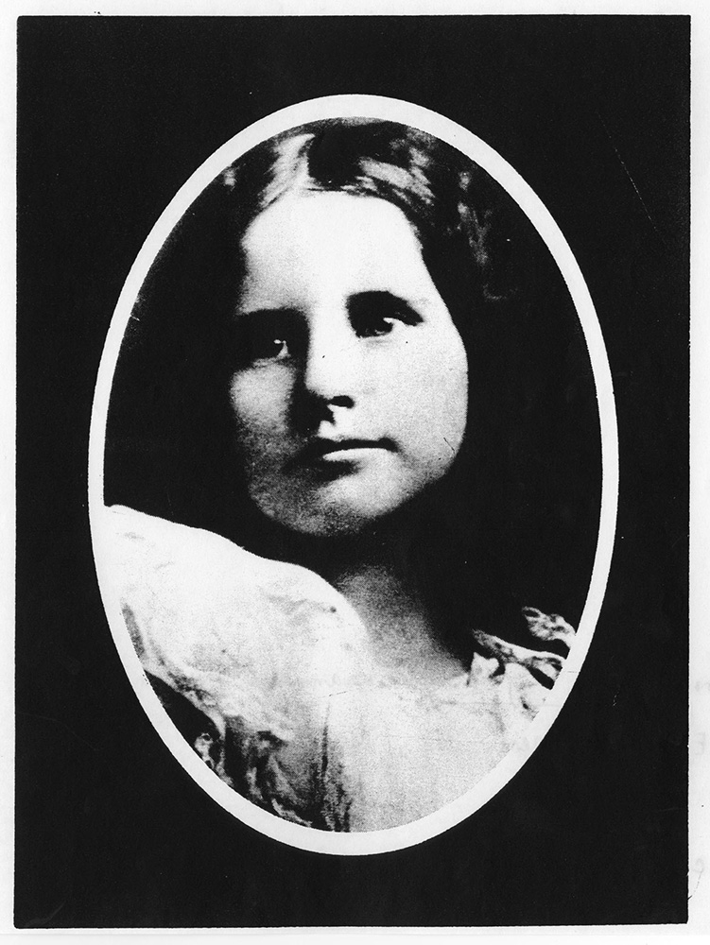
Virginia was born July of 1889. She went on to get an education at three colleges, receiving a BA from Hunter College, a master's degree in education from Columbia University, and a doctorate of philosophy in the faculty of education from Fordham University. At Fordham, she wrote a dissertation, which is a long essay/thesis for her major. Her’s was entitled, "The Importance of Play”. It is very ironic that after this very well known incident of a girl just trying to keep her faith in Santa Claus, she writes one of the most important essays of her life on how faith in the youth of our world is so incredibly important for their growth. Virginia hits her readers with her point from the very beginning, opening her piece literature by saying, “While reading the ‘Principles of Educational Sociology’ by Walter Robinson Smith, the writer was deeply impressed by the statement that ‘Next to the family group and home life, the play group and play life exert the most vital influence upon the unfolding personality of the child.’ The writer wondered if it was the absence of play life, as American born children of fair social background experience it, that would in some measure explain the dullness of the Italian-American child of Sicilian and Neapolitan origin…” Virginia received much fan mail throughout her entire life after the iconic exchange of letters debating Santa Claus. In all of her responses to her fans, she would attach a copy of this editorial, “The Importance of Play”. Virgina connected with her fans on such a personal level, enough to want to write back to them, as well as prove why faith in children holds so much power. It’s fascinating to see how she connects the dots between this moment of her life as a child, and then in early adulthood, and how her point of view remained the same, so pure and full of wonder! Just 2 months before her death, a picture was taken of her at her nursing home, and the one and only Santa Claus visiting her, seen here:
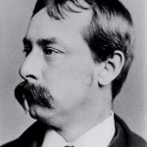
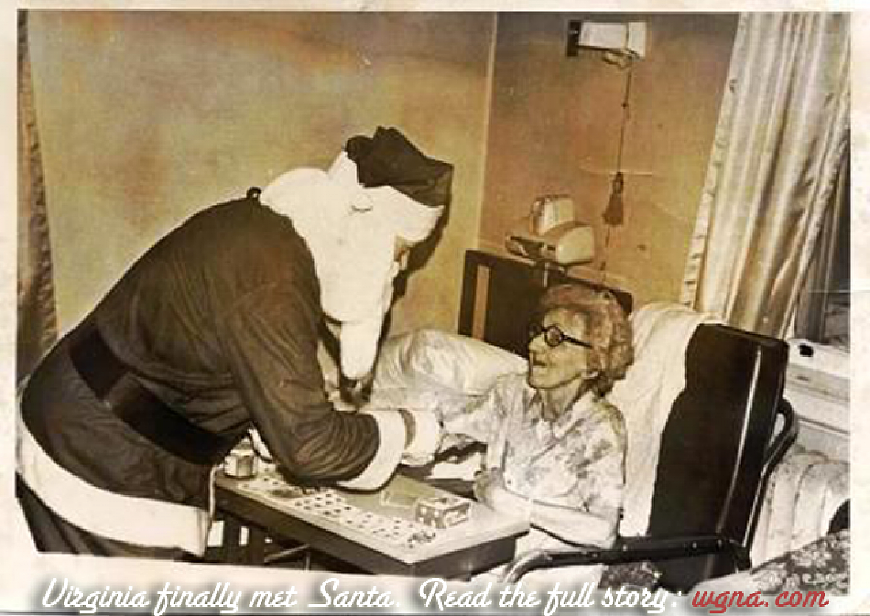
Francis P Church was not a man to refer to as “child-like” or “wonderous”, but the complete opposite. He is referred to as a ‘curmudgeonly journalist’. The article, `The Journalist Who Understood the True Meaning of Christmas’ describes him as, “A sardonic, childless writer… Francis hardly seems like the fun dude at the holiday party. And yet, he’s responsible for composing one of the most thoughtful and beloved holiday pieces of all time.” Church comes from a very high achieving family of doctors, a Revolutionary war veteran, and the founder of Salem Massachusetts! Like Virginia, he too went to Columbia university. Afterwards, he worked in the legal system for a little while, but ultimately ended up becoming a writer. His first works were two papers that he published with his brother. They founded The Army and Navy Journal in 1863, and in 1866, the Galaxy (a magazine that notably published articles by Walt Whitman and Mark Twain, which later merged with The Atlantic Monthly, giving us now, The Atlantic). Later, he went on to serve as a lead editorial writer on William’s newspaper, The New York Sun, for many years. It is easy to see that Church was one to pen editorials for only a series of highly-reputable publications. He seems studious, smart, and sophisticated. There is no surprise that when this 8 year old girl’s letter questioning Santa Claus was flopped onto his desk, he did not appreciate the assignment; he wanted nothing to do with it, or this child! Regardless, he ended up writing back, and thank goodness he did, because he showed Virginia (and eventually the whole world) the true meaning of Christmas!
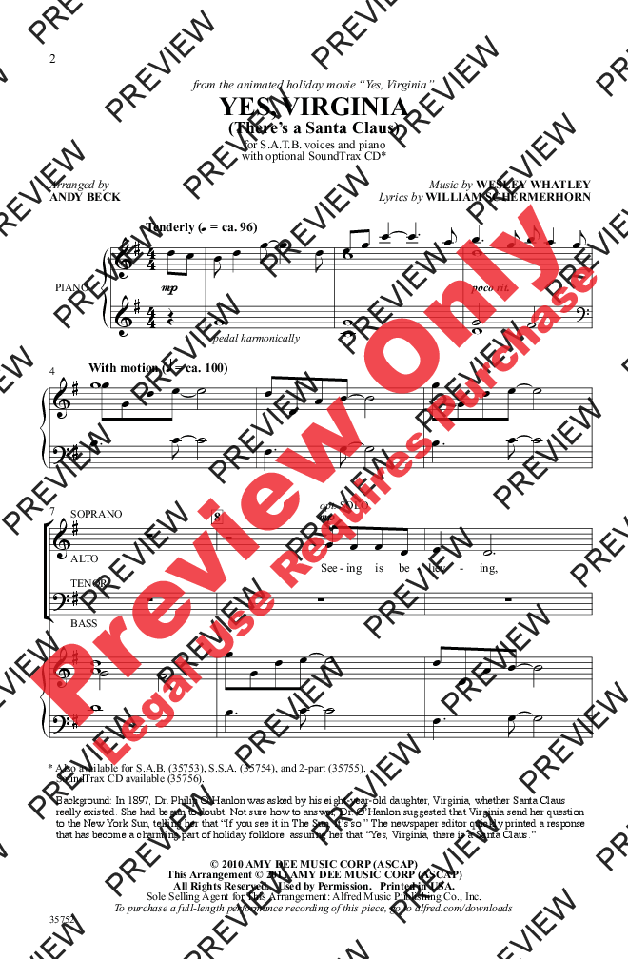
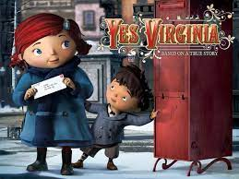

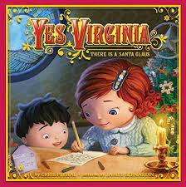
This letter, both physically and creatively, is all over the place! It was long rumored that the original letter of “Yes, Virginia'' was burnt and destroyed in a house fire. Luckily, in February of 2001, the History Channel aired a special on this, and confirmed that the letter is actually safe and sound in a scrap book that Virginia’s granddaughter currently possesses. Globally, this letter has expanded into so many forms. For one, it was translated into twenty languages! Warner Brothers picked it up in 2009 and created an animated short film of it. It also became a children's book, and a song,
"Yes, Virginia, there is a Santa Claus", that is popularly sung at children’s Christmas holiday concerts! Majority of the song lyrics come directly from the original letter itself! This letter is also read aloud every year as part of the Yule Log ceremony at Columbia University, a college that they both attended!

A commonly used phrase in today’s world is that “beauty lies in the eyes of the beholders”, but, Church shows all of us here that actually, true beauty lies in the heart, mind, and spirit of the beholder! A life without Santa Claus would be life without another aspect of imagination, faith, love, and belief beyond the eyes’ vision; this kind of outlook leads to a pretty dull life, according to Virginia, especially if that spirit of faith and belief is stripped away at a young age. The article, ‘The Journalist Who Understood the True Meaning of Christmas’ sums up Francis’ legacy here nicely, saying, “Even today, Francis’ elegant response to an innocent child is lauded as a journalistic feat: Without ever pandering, the editorial reinforces the idea that faith — not skepticism — makes life worth living.” Thanks to this wonderfully crafted open letter, we as a society have a perfect answer regarding questions referring to Santa’s relevance and existence. So yes, I am a freshman in college, yes I am of legal adult age, and yes, I do believe in Santa Claus. Why would I choose to live a life without those aspects of faith and wonder? Now, next time someone asks you if Santa is real, you too have the perfect response, thanks to Francis P Church and Virginia.

CITES
- https://www.newseum.org/exhibits/online/yes-virginia-there-is-a-santa-claus/

- Letters of Note: Volume 1 : An Eclectic Collection of Correspondence Deserving of a Wider Audience, Chronicle Books LLC, 2014. ProQuest Ebook Central, http://ebookcentral.proquest.com/lib/muhlenberg/detail.action?docID=5195213.
Created from muhlenberg on 2021-10-28 18:41:37.

- https://en.wikipedia.org/wiki/Yes,_Virginia,_there_is_a_Santa_Claus

- http://omgfacts.com/the-journalist-who-understood-the-true-meaning-of-christmas/ !!!!

